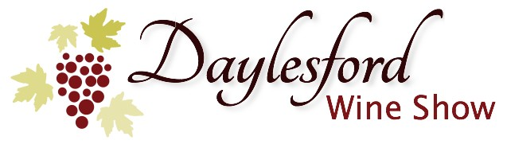

# DAYLESFORD WINE SHOW 2019

# RESULTS BOOK

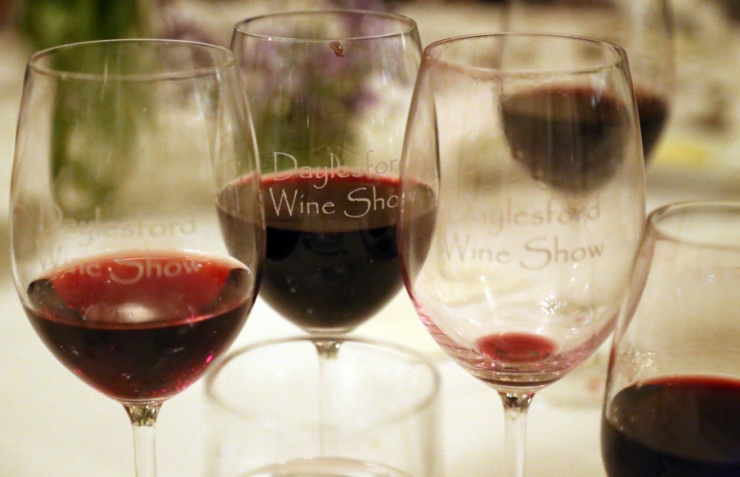

**SPONSORS**

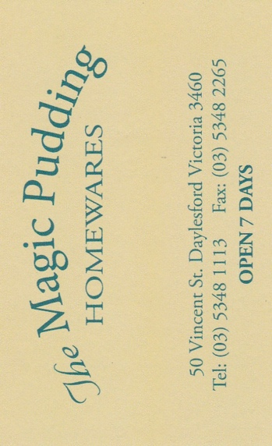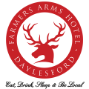

../Sponsor%20Logos/cellarbrations-logo.jpg

### ../Sponsor%20Logos/GrandeHepburn.jpg

### The Daylesford Wine Show acknowledges the support and generosity of all our sponsors, in particular our major sponsor, Lake House, Daylesford, where the judging and award dinner is held. The continued support of our sponsors over the past sixteen years has been essential to the success of the Daylesford Wine Show, we thank them.

The Daylesford Wine Show also acknowledges the support of Legion Office Works, Castlemaine.

**TROPHIES**

|  |  |
| --- | --- |
| **Best Wine in Show**  The Lake House Trophy | **Galli Estate**  2017 Pamela Sunbury Chardonnay |
| **Best Red Wine in Show**  The Farmers Arms Trophy | **Hesket Estate**  2018 Pinot Noir |
| **Best Sparkling Wine**  The Kilchurn Sparkling Wine Specialist Trophy | **Parkside Estate**  2013 Chardonnay Pinot Noir |
| **Best White Wine other than Chardonnay**  The Central Springs Inn Trophy | **Black Wallaby Wines**  2017 Albino Blend |
| **Best Chardonnay**  The Springs Medical Centre Trophy | **Galli Estate**  2017 Pamela Sunbury Chardonnay |
| **Best Pinot Noir**  The Grande Hotel Trophy | **Hesket Estate**  2018 Pinot Noir |
| **Best Shiraz**  The Cellarbrations at Foxxy’s Trophy | **Hennings Vineyard**  2017 Croquet Shiraz |
| **Past Presidents Award**  The Best Red Wine 6+ years Old) | **Killiecrankie Wines**  for their 2013 Shiraz |
| **Julian West Memorial Trophy**  Sponsered by  Baird & Mc Gregor Lawyers  Awarded to a small winery (<25 tonnes) which makes its own wine, on the basis of scores on the top 3 wines | **Killiecrankie Wines**  John Monteath (winemaker) |

**CLASS A**

Sparkling Wine

**Class comments:**

Difficult class to judge with so many styles and varietals. Top wine was a standout with 4 golds. All the classic hallmarks of sparkling a benchmark wine. Some good examples of other varieties.

**CLASS B**

White wine other than Chardonnay

**Class comments:**

Best wines are varietal and intense with good length and balance

CLASS C

Chardonnay



**Class comments:**

Generally, a strong class. The best wines with very smart fruit and oak balance. 2017 wines have developed very well.

## CLASS D

Rosé

|  |  |  |  |  |
| --- | --- | --- | --- | --- |
| **Winery** | **Commercial Name if supplied** | **Vintage** | **Score** | **Medal** |
| Killiecrankie | Crankie Rosé | 2019 | 52 | S |
| Galli Estate | Camelback Heathcote Nebbiolo Rosé | 2019 | 49.5 | B |
| Glenwillow | Rosé | 2019 | 48 | B |
| Black Wallaby Wines | Ruby Rosé | 2018 |  |  |
| Balgownie Estate | Rosé | 2019 |  |  |
| Harcourt Valley Vineyards | Rosé | 2019 |  |  |
| Coliban Valley | Rosé | 2019 |  |  |
| Nintingbool | Rosé | 2018 |  |  |
| Harcourt Valley Vineyards | Dr Livingstone Rose´ | 2018 |  |  |
| Lord Malmsbury Vineyard | Master Nicholas Rosé | 2019 |  |  |

**Class comments:**

Disappointing class a bit too commercial in true rose varietals reduction an issue in some wines.

**CLASS E**

Pinot Noir

**Class comments:**

Generally good fruit used well. Nice tannins, most well made. Very uniform class, generally strong on average.

## CLASS F

Merlot and blends

|  |  |  |  |  |
| --- | --- | --- | --- | --- |
| **Winery** | **Commercial Name if supplied** | **Vintage** | **Score** | **Medal** |
| Coliban Valley | Merlot | 2018 | 48.5 | B |
| Welshmans Reef | Merlot | 2018 | 48 | B |
| Killiecrankie | Merlot | 2017 | 46.5 | B |
| Lord Malmsbury Vineyard | Marisé Merlot | 2018 |  |  |
| Farmers Arms | The Moonchaser Merlot Refesco | 2018 |  |  |

**Class comments:**

Poor old Merlot! Reduce yields and give it a shot.

## CLASS G

Shiraz and shiraz blends (>85% shiraz)

|  |  |  |  |  |
| --- | --- | --- | --- | --- |
| **Winery** | **Commercial Name**  **if supplied** | **Vintage** | **Score** | **Medal** |
| Killiecrankie | Shiraz | 2013 | 55.5 | G |
| Hennings Vineyard | Croquet Shiraz | 2017 | 55.5 | G |
| Hennings Vineyard | Shiraz | 2017 | 52.5 | S |
| St Annes Vineyard | Tatalia Heathcote Shiraz | 2016 | 51 | S |
| Idavue Estate | Heathcote Shiraz | 2017 | 50.5 | B |
| Balgownie Estate | Estate Shiraz | 2017 | 50 | B |
| St Annes Vineyard | Heathcote Shiraz | 2017 | 49 | B |
| Water Wheel | Bendigo Shiraz | 2015 | 49 | B |
| Idavue Estate | Blue Note Shiraz | 2013 | 49 | B |
| Idavue Estate | Heathcote Shiraz | 2012 | 49 | B |
| Harcourt Valley Vineyards | Barbara’s Shiraz | 2017 | 48.5 | B |
| Harcourt Valley Vineyards | Old Vine Shiraz | 2016 | 48.5 | B |
| Peregrine Ridge | American Oak Blend | 2013 | 48.5 | B |
| Peregrine Ridge | Limited Release Shiraz | 2013 | 48.5 | B |
| Harcourt Valley Vineyards | Mt Camel Range Shiraz | 2016 | 48 | B |
| Coliban Valley | Reserve Shiraz | 2017 | 47.5 | B |
| Harcourt Valley Vineyards | Barbara’s Shiraz | 2018 | 47.5 | B |
| Bowerbird Estate | Shiraz | 2017 | 47.5 | B |
| Killiecrankie | Shiraz | 2017 | 47.5 | B |
| Idavue Estate | The Sawmillers Shiraz | 2017 | 47 | B |
| Idavue Estate | Heathcote Shiraz | 2013 | 47 | B |
| Witchmount Estate | Lowen Park Shiraz | 2017 | 46.5 | B |
| Peregrine Ridge | Shearstone Shiraz | 2013 | 46.5 | B |
| Peregrine Ridge | Limited Release Shiraz | 2009 | 46.5 | B |
| Black Wallaby Wines | Estate Shiraz | 201 |  |  |
| Glenwillow | Reserve Shiraz | 2014 |  |  |
| Water Wheel | Memsie Shiraz | 2015 |  |  |
| Farmers Arms | The Moonchaser Shiraz Refosco | 2018 |  |  |
| Glenwillow | Shiraz | 2017 |  |  |
| Balgownie Estate | Nouveau Syrah | 2019 |  |  |
| Lord Malmsbury Vineyard | Ziena Shiraz | 2018 |  |  |
| Barfold Estate | Shiraz | 2015 |  |  |
| Harcourt Valley Vineyards | Dr Livingstone Shiraz | 2017 |  |  |
| Coliban Valley | Shiraz | 2017 |  |  |
| Galli Estate | Camelback heathcote Shiraz | 2017 |  |  |
| Witchmount Estate | Estate Shiraz | 2016 |  |  |

**Class comments:**

Generally disappointing class with only a couple of standout wines. Older wines looked very solid. Vintage 2017 wines showed the cold wet season. Almost appears we have become complacent with Shiraz. Too much stalk and whole bunch is not a good thing.

Best wines are balanced with no single character dominating.

## CLASS H

Cabernet Sauvignon (>85% Cabernet Sauvignon)

|  |  |  |  |  |
| --- | --- | --- | --- | --- |
| **Winery** | **Commercial Name if supplied** | **Vintage** | **Score** | **Medal** |
| Barfold Estate | Cabernet Sauvignon | 2015 | 51 | S |
| Coliban Valley | Cabernet Sauvignon | 2018 | 49 | B |
| St Annes Vineyard | Heathcote Cabernet Sauvignon | 2017 | 49 | B |
| Balgownie Estate | Estate Cabernet Sauvignon | 2012 | 48.5 | B |
| St Annes Vineyard | Tatalia Heathcote Cabernet | 2016 | 47 | B |
| Harcourt Valley Vineyards | Cabernet Sauvignon | 2018 |  |  |
| Balgownie Estate | Estate Cabernet Sauvignon | 2015 |  |  |
| Zig Zag Wines | Cabernet Sauvignon | 2013 |  |  |
| Lord Malmsbury Vineyard | John’s Reserve | 2018 |  |  |
| Idavue Estate | Cabernet Sauvignon | 2016 |  |  |
| Glenwillow | Cabernet Sauvignon | 2016 |  |  |

**Class comments:**

Generally disappointing many green and herbal wines. Wines need more ripeness, depth and oak.

**CLASS I**

Bordeaux Blends ie Cabernet Sauvignon, Cabernet Franc, Merlot, Petit Verdot, Malbec, etc in any proportions.

**Class comments:**

Generally disappointing many green and herbal wines. Wines need more ripeness, depth and oak.

## CLASS J

## Italian Varieties

**Class comments:**

Good development in quality of so called alternate varieties. A couple of VA and Oak issues which are easily addressed.

## CLASS K

## Other reds and blends

|  |  |  |  |  |
| --- | --- | --- | --- | --- |
| **Winery** | **Commercial Name if supplied** | **Vintage** | **Score** | **Medal** |
| Galli Estate | Camelback Grenache | 2018 | 51.5 | S |
| Galli Estate | Heathcote Tempranillo Grenache Mourvedre | 2017 | 49.5 | B |
| St Annes Vineyard | Tatalia Private Reserve Shiraz Cabernet | 2015 | 48 | B |
| Killiecrankie | Triskelion | 2016 | 47.5 | B |
| Mount Charlie Vineyard | Dry Red | 1996 | 47 | B |
| Mount Charlie Vineyard | Shiraz Merlot | 2005 |  |  |
| Mount Charlie Vineyard | Malbec | 2016 |  |  |

**Class comments:**

Some very good examples of other varietals. Good work in the vineyard is evident in the wine.

JUDGING PANEL

**Judges**

Victor Nash (Winemaker, Fowles Wines, Strathboggie)

Simon Osicka (Osicka Wines, Greytown)

Lilian Carter (Consultant Winemaker)

**Associate Judge**

Ben Kimmorley (Asst. Winemaker Curly Flat)

**Stewards**

Eric Bellchambers * (ex Zig Zag Wines), Show Co-ordinator

David Rush * (Lord Malmsbury), Chief Steward

Sandra Aitken (Barfold Estate), Recorder

Helen Miles * (Coliban Valley), Recorder

Charles Zhang *

Darryl Ward (Parkside Estate)

Ian Watson (Tomboy Hill)

Greg Miles * (Coliban Valley)

Cameron Atkins

David Lawson (Black Wallaby Wines)

* Members of the DWS Committee

